Name: Rithik Sarvesh Bharathiraja

UID: 120395246

Course: ENPM693

Task: Homework 6

Part – 1

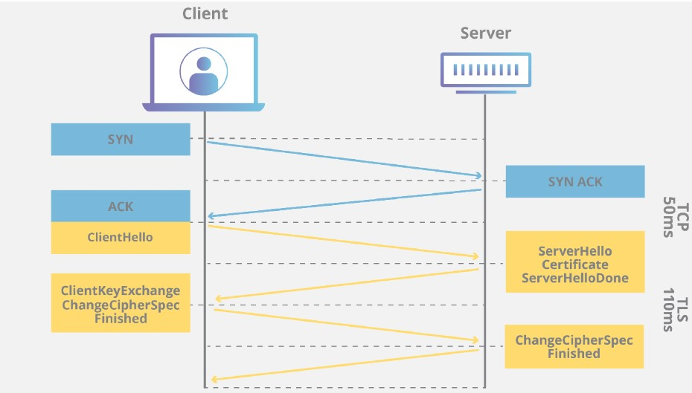

This is a packet capture of the conversation between the client and badssl.com

Client hello

Following important parameters are sent to the server in the client_hello message

Version – TLS version

Timestamp – to prevent replay attack

random bytes - generated by the client

Session ID – To check whether the connection was established already.

Cipher suites – The types of cipher suites supported by the client

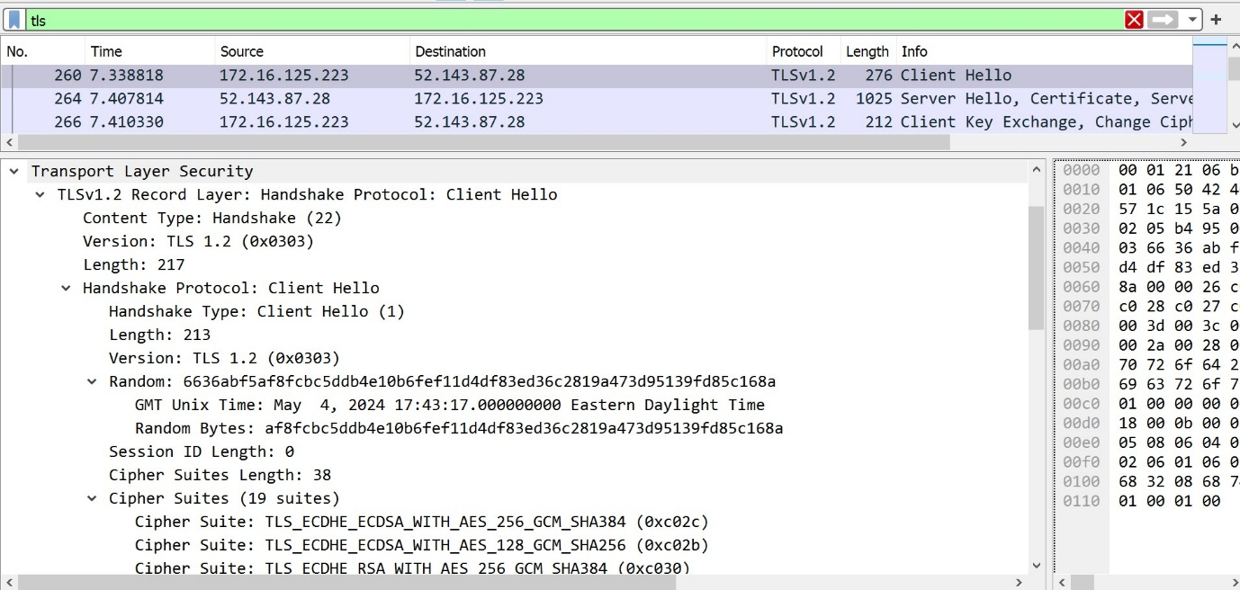

Server hello

In response to client hello, server sends the server_hello message. In this, server chooses the cipher suite and sends that to the client. Along with that, session is established and unique session ID is generated and sent to the client.

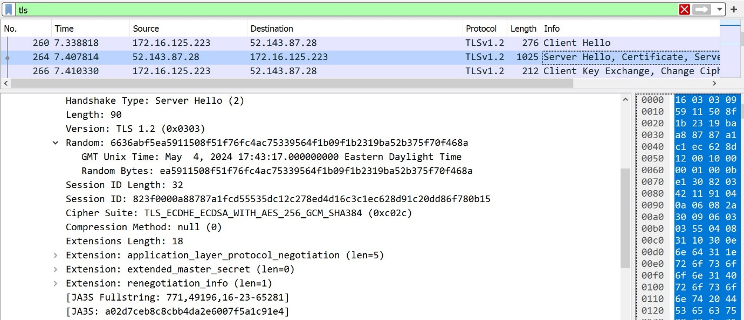

After server_hello, the server sends its certificate to the client.

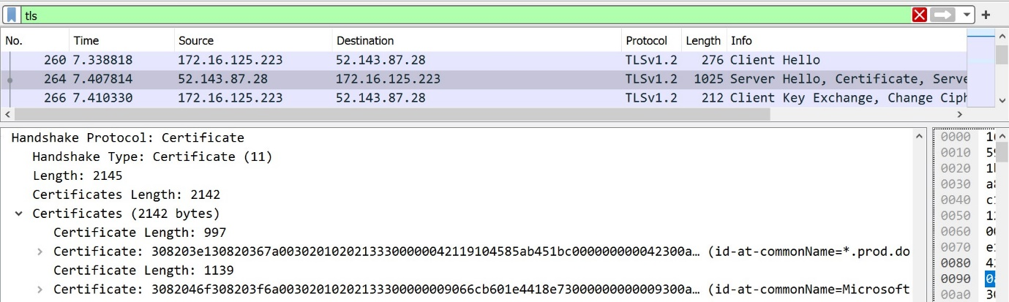

In certificate, it comes up with various important parameters like

* Signature
* Issuer
* Validity
* Subject

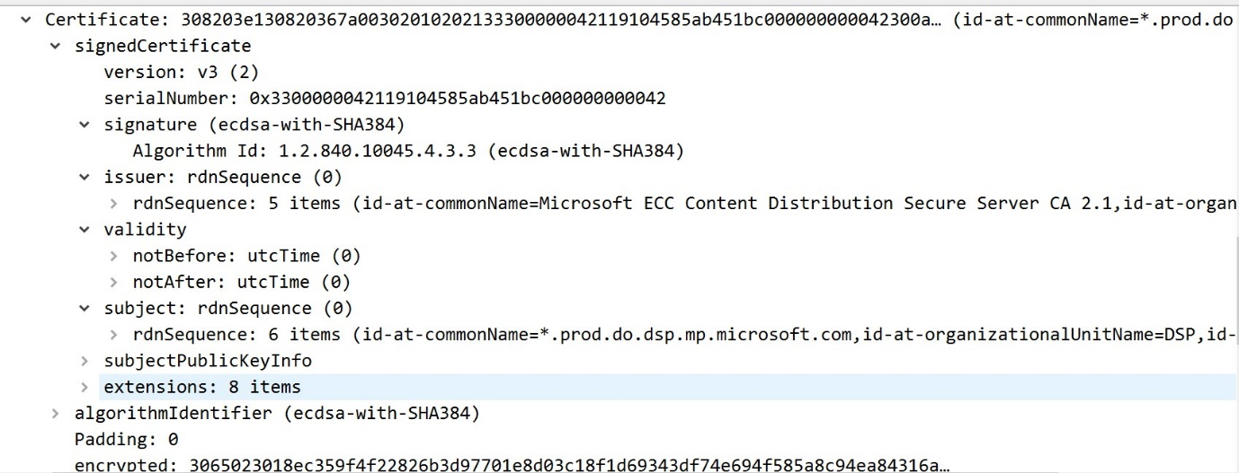

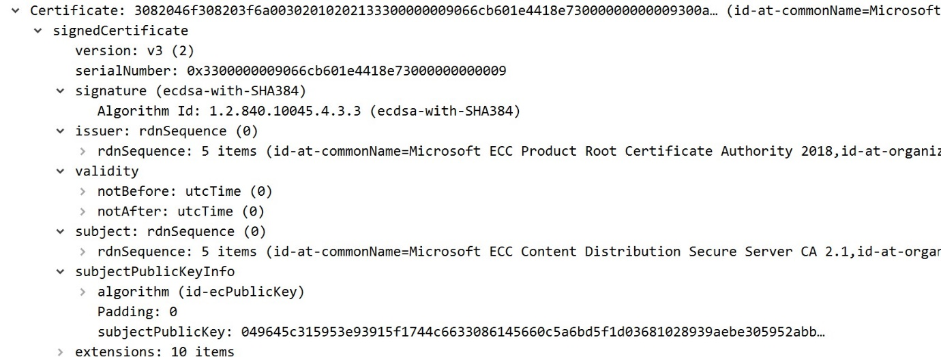

To exchange keys, server sends the key exchange algorithm and its parameter.

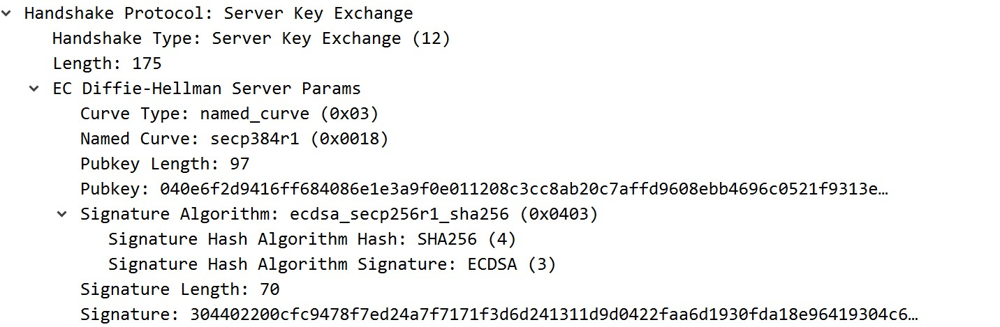

At last, the server sends the server_hello_done message to mark the end of server hello

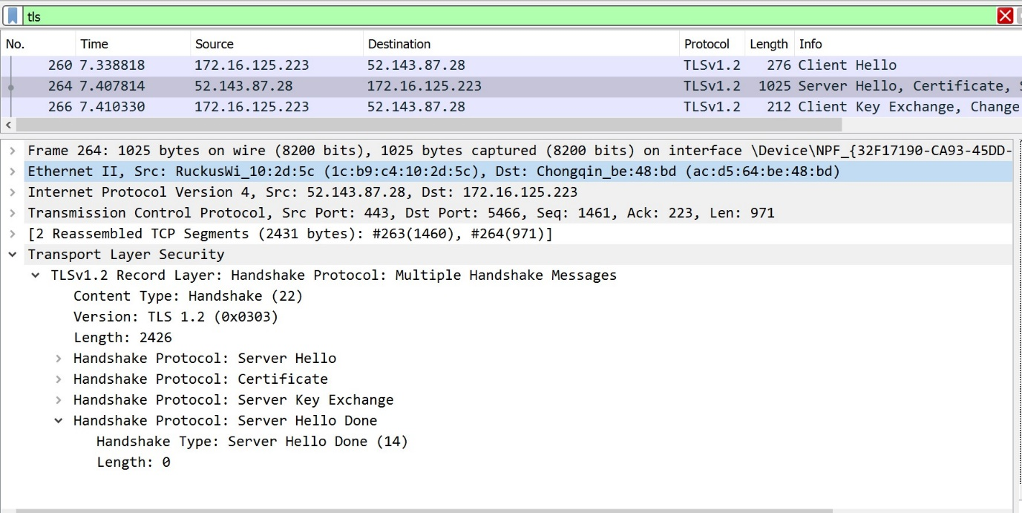

Client key exchange and cipher change spec

In response, the client sends its parameter for key exchange and it acknowledges that the server has chosen a cipher suite.

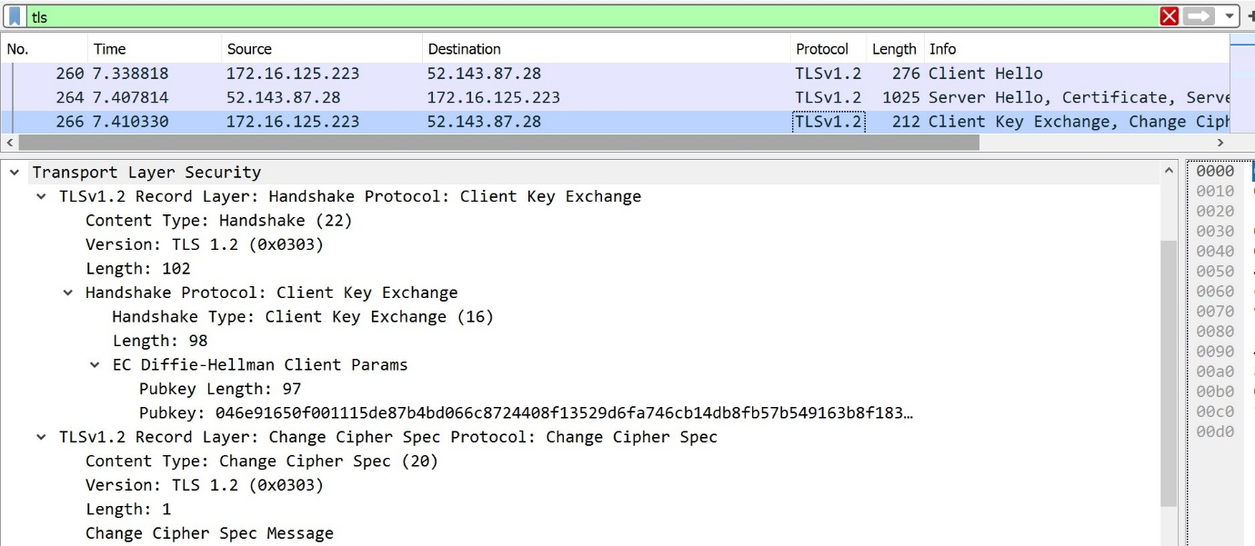

Server reply

Server acknowledges the client’s acknowledgement and starts sending in the data after that.

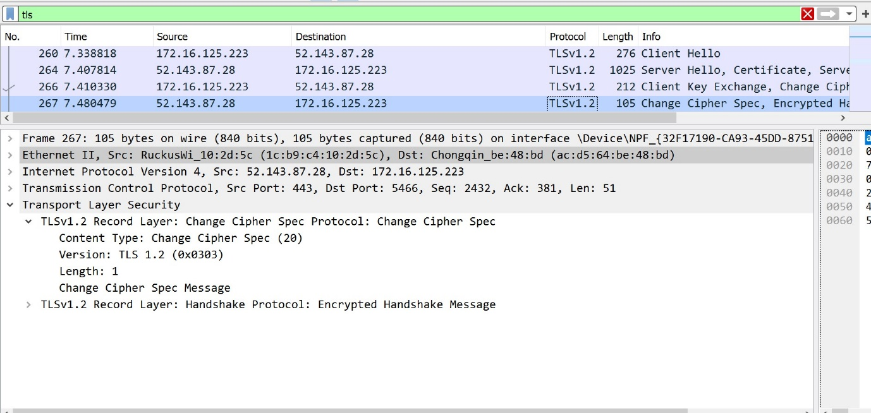

Part 2

After following the given steps, packet capture was done after accessing https://www.iplt20.com website. Using the sslkeylog.txt, wireshark decrypts the data sent in the https. At the end, readable html tags were found in the below tab.

